ASSIGNMENT:1
1.
Sign up for a free AWS or Azure account and log in to the Management Console. Take a screenshot of your dashboard showing your name or email in the top bar.
ANS :
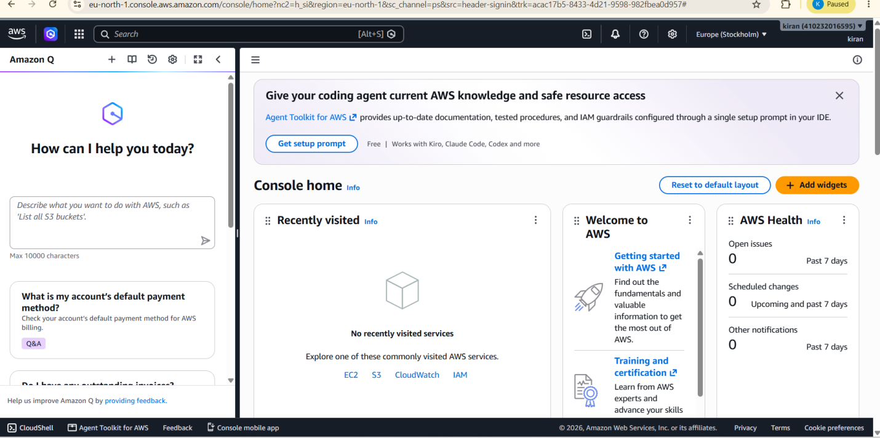

2.
In the AWS or Azure Management locate and list 5 key services (such as Compute, Storage, Database, Networking, Analytics). For each, write one line describing what it does and name one real app (like Instagram, Zomato, Flipkart) that could use it.
ANS :
1. Amazon EC2 – Compute: Amazon EC2 provides virtual servers for running applications and websites. Example: Instagram.
2. Amazon S3 – Storage: Amazon S3 stores files, images, videos, documents, and backups. Example: Instagram.
3. Amazon RDS – Database: Amazon RDS provides managed relational databases for storing application data. Example: Zomato.
4. Amazon VPC – Networking: Amazon VPC creates a secure private network for AWS resources. Example: Flipkart.
5. Amazon Redshift – Analytics: Amazon Redshift analyzes large amounts of data and helps businesses generate useful insights. Example: Flipkart.

3.
Use the search bar in your AWS or Azure Console to find the S3 (AWS) or Blob Storage (Azure) service. Write down the steps you took to locate it and describe in 2-3 lines how a music app like Spotify could use this service to store user-uploaded files.
ANS :
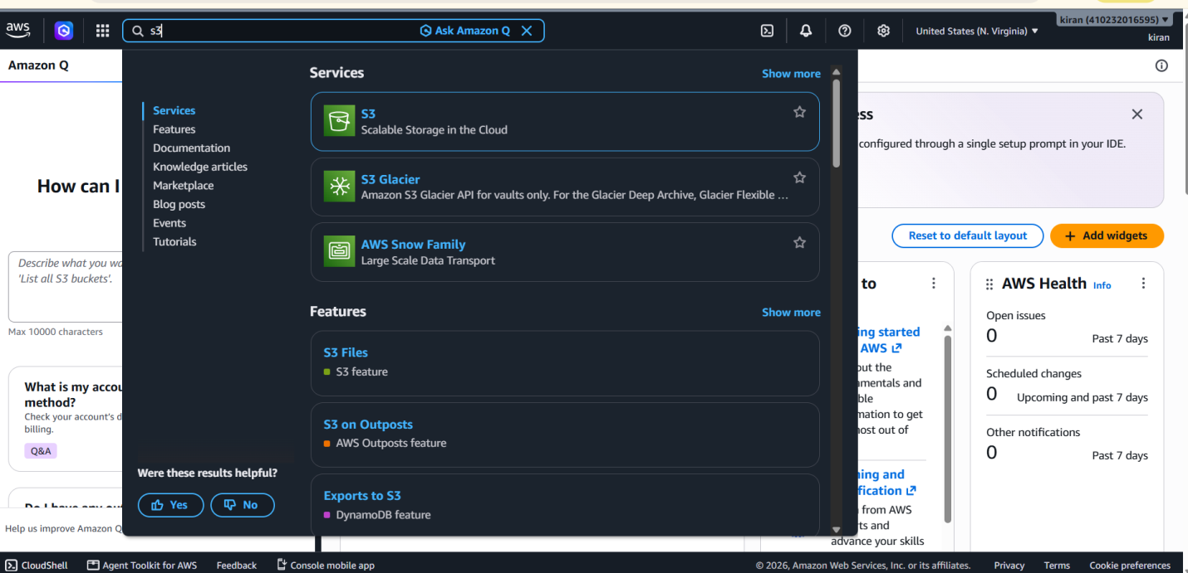
Amazon S3 can be used by a music app like Spotify to store user-uploaded files such as music tracks, podcasts, audio recordings, and profile images. S3 provides scalable and secure cloud storage, allowing the app to store and retrieve large amounts of user data when needed.

4.
Pick one key characteristic of cloud computing (on-demand self-service, broad network access, resource pooling, rapid elasticity, or measured service) and explain, in your own words, how it benefits users of a popular app you use daily (e.g., Paytm, BookMyShow, IRCTC).<br><br><em><strong>Hint:</strong> Think about how these apps handle sudden spikes in users or data.</em>
ANS :
Cloud Computing Characteristic: On-Demand Self-Service
On-demand self-service means users can access services and resources whenever they need them without having to contact the service provider. For example, Instagram can use cloud computing to provide users with photos, videos, messages, and other features whenever they open the app. This makes the app fast and convenient for users because resources can be provided automatically when needed.

